# Algorithm for file updates in Python

## Project description

You are a security professional working at a health care company. As part of your job, you're required to regularly update a file that identifies the employees who can access restricted content. The contents of the file are based on who is working with personal patient records. Employees are restricted access based on their IP address. There is an allow list for IP addresses permitted to sign into the restricted subnetwork. There's also a remove list that identifies which employees you must remove from this allow list.

Your task is to create an algorithm that uses Python code to check whether the allow list contains any IP addresses identified on the remove list. If so, you should remove those IP addresses from the file containing the allow list.

## Open the file that contains the allow list

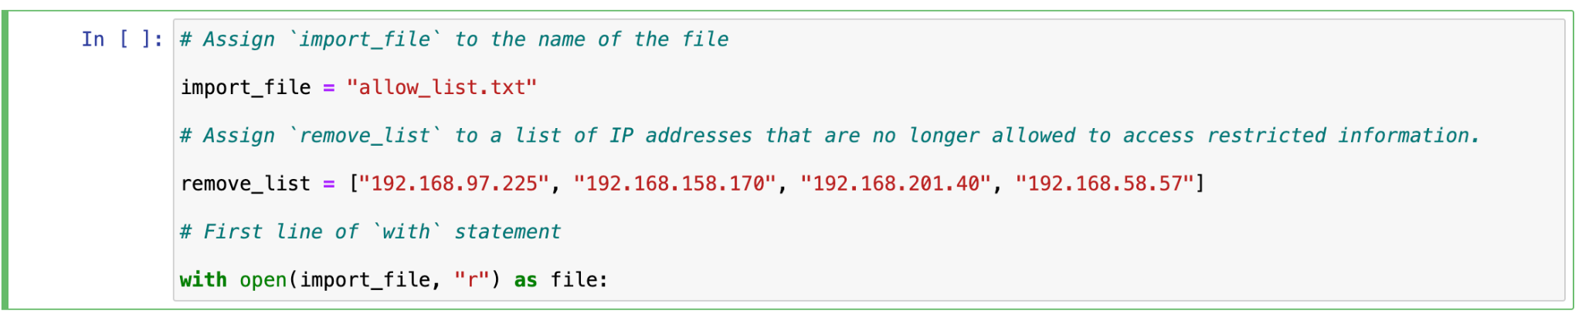

As can be seen in the code above, the “allow_list.txt” file name is stored in import_file variable, which is used to open the file to be read later. Also, a list of IP addresses that are needed to be removed is specified in the remove_list variable.

## Read the file contents

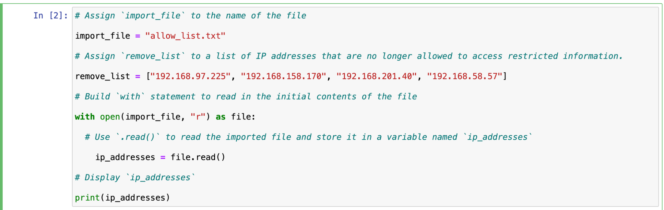

Then the file’s content is stored in the ip_addresses variable to print it later.

## Convert the string into a list

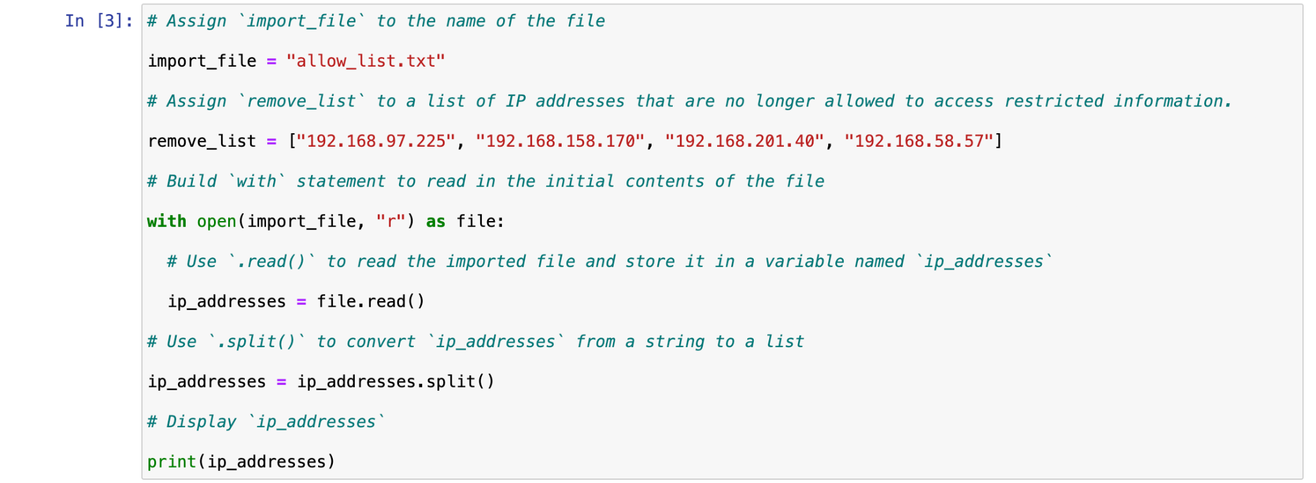

The string variable is converted to a list using .split() built-in method, and stored in the same variable.

## Iterate through the remove list

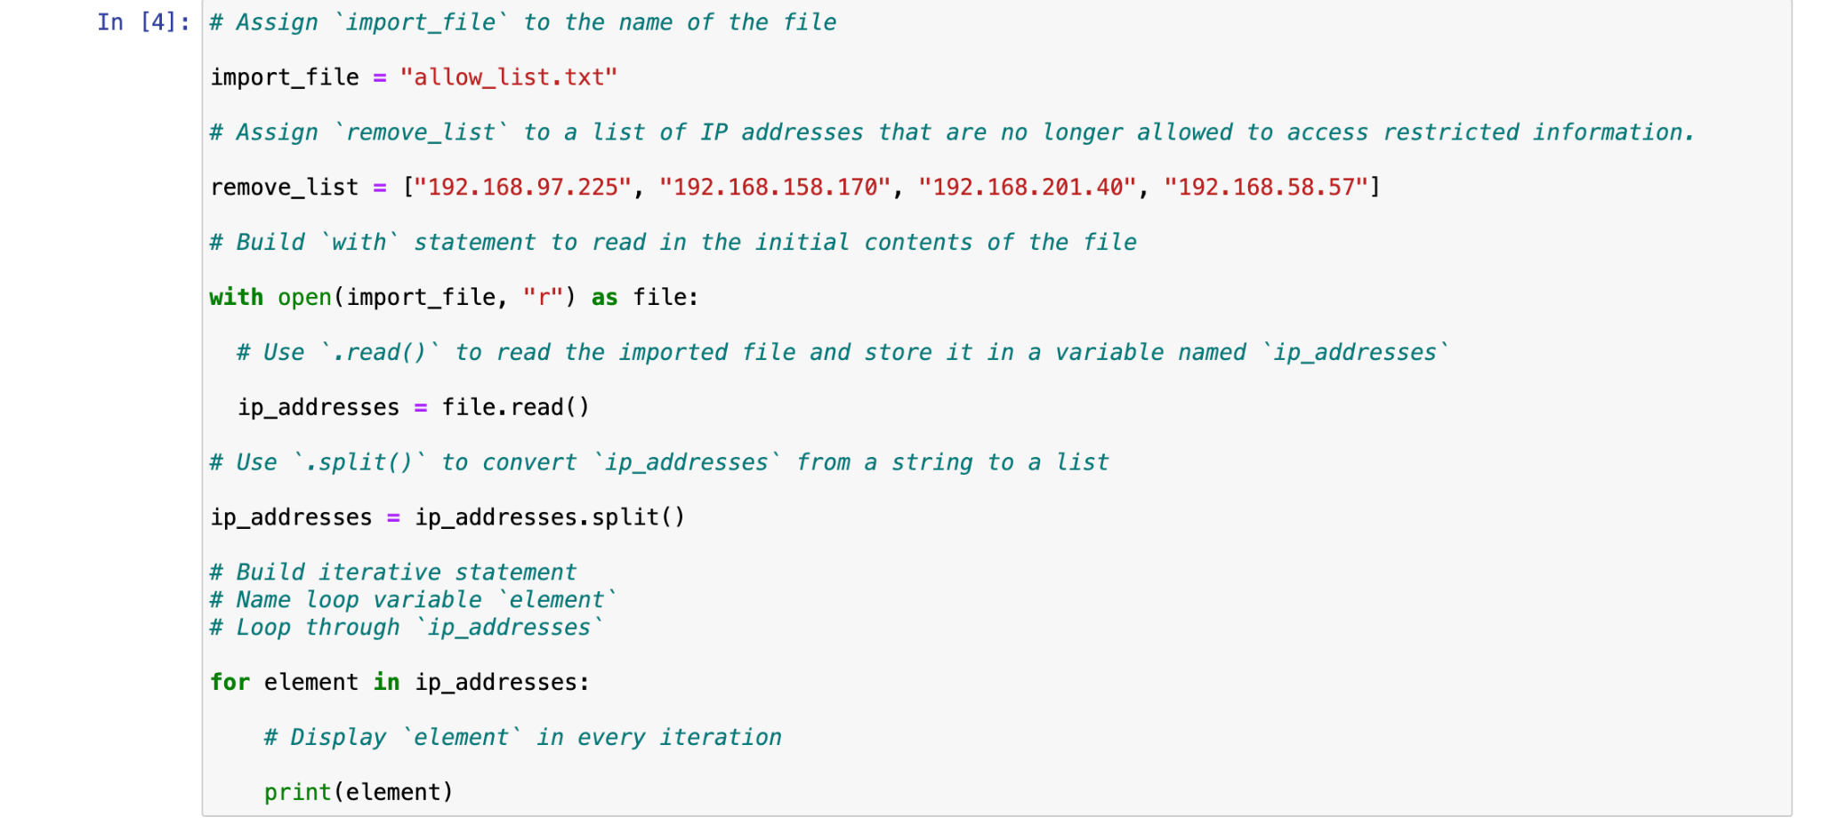

An iteration takes place on the elements of the list, to help us find the IP addresses that are needed to be removed.

## Remove IP addresses that are on the remove list

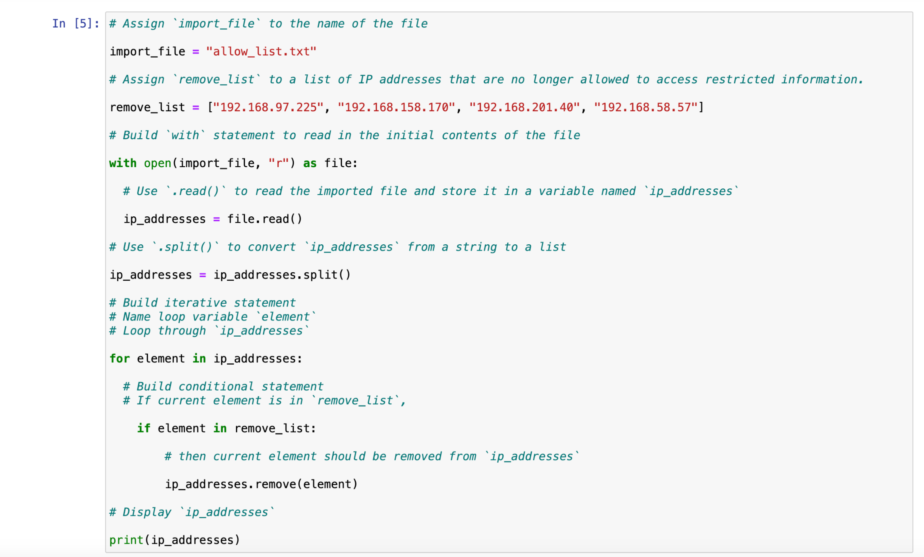

Bad elements are removed from the list and the list is printed to assure the correctness of the process.

## Update the file with the revised list of IP addresses

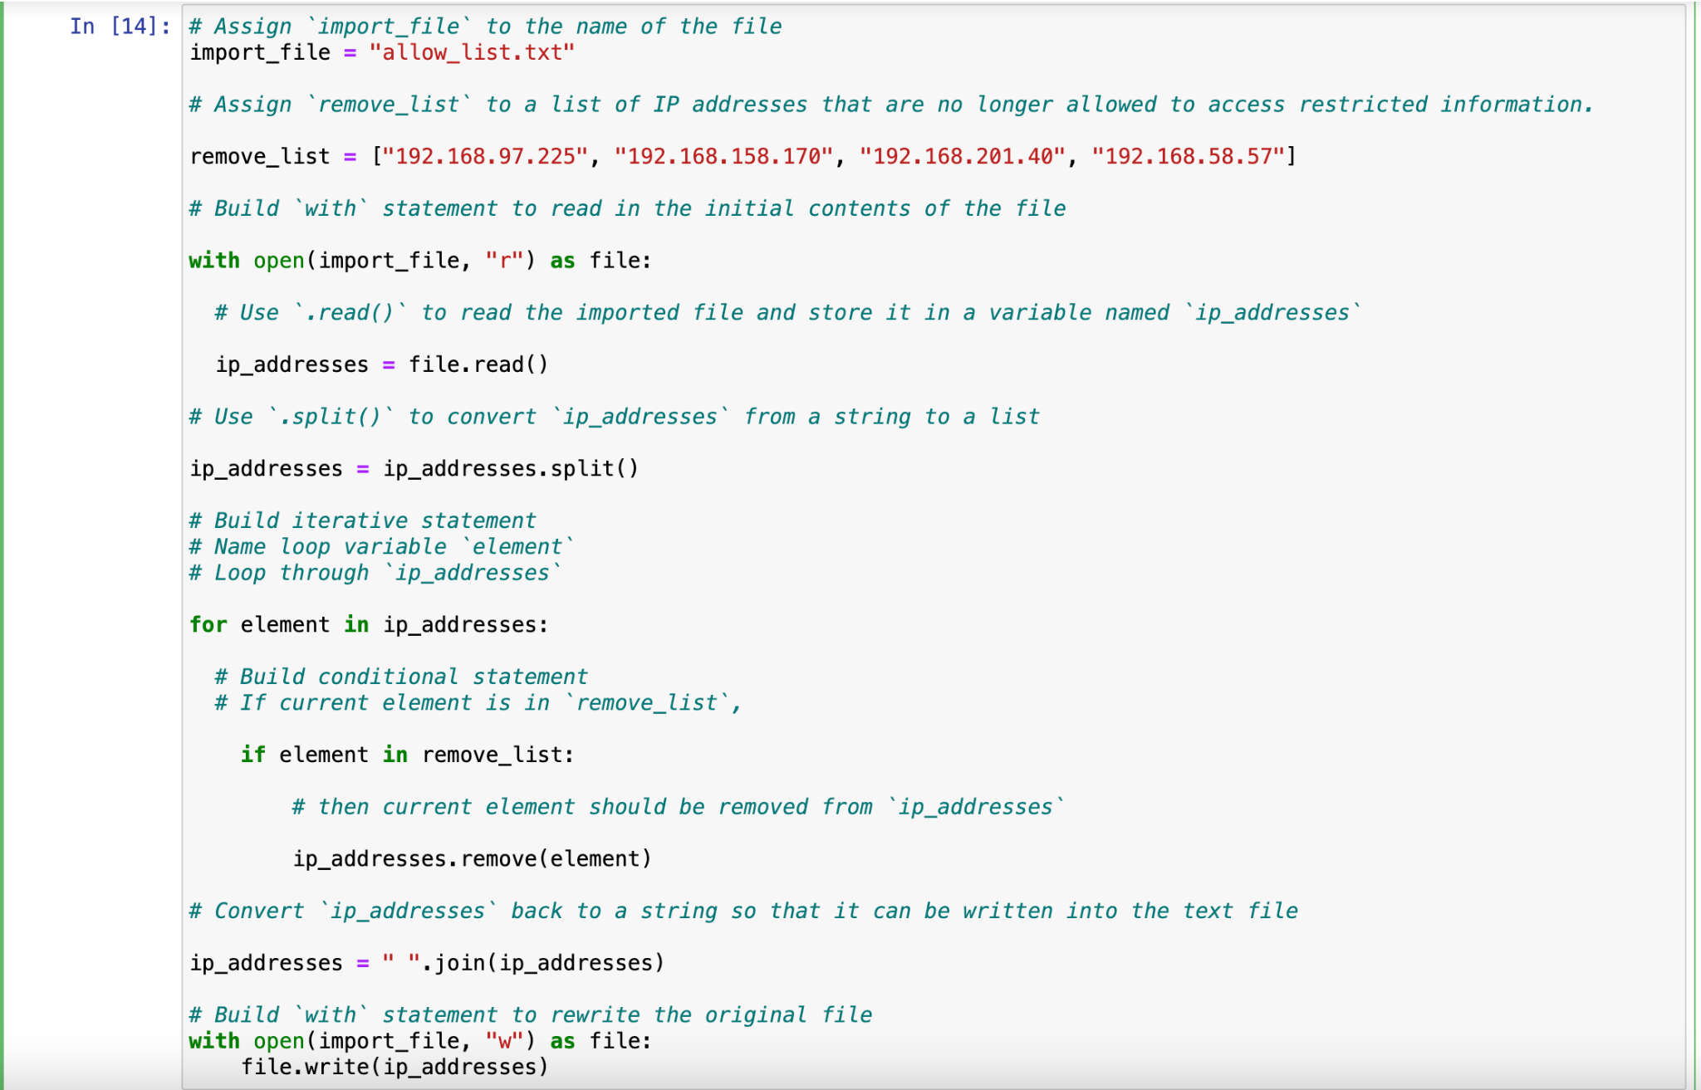The updated list is stored (written) on the file, i.e. the file is updated with the new list.

## Summary

In this lab, we tried to read from a file, update the content and rewrite the file with the new content, using Python programming language. The update process was to remove some predefined IP addresses from the list of IP addresses stored in the allow_list.txt file.